1. Web server: qq.com IP address: 111.161.64.40 or 111.161.64.48
2. University Name: Technical University of Munich

Website: [www.tum.de](http://www.tum.de)

Authoritative DNS server: dns1.lrz.de ; dns2.lrz.bayern;dns3.lrz.eu

1. Type the command as this: nslookup -type=MX yahoo.com dns1.lrz.de

And the result is:

Dns1.lrz.de can’t find yahoo.com: Query refused.

1. The DNS query is number 277. The response message is number 408.

They are sent over UDP protocol.

1. Destination port: 53, address: 161.253.152.241

DNS response message source port: 53, address: 161.253.152.241

1. The DNS query is sent to 161.253.152.241

My local DNS server is 161.253.152.241, they are same as each other.

1. It is a type-A query. No
2. Two answers are provided:
3. iaoc.ietf.org: type CNAME, class IN, cname ietf.org Name: iaoc.ietf.org Type: CNAME (Canonical NAME for an alias) (5) Class: IN (0x0001) Time to live: 1800 Data length: 2 CNAME: ietf.org
4. ietf.org: type A, class IN, addr 4.31.198.44 Name: ietf.org Type: A (Host Address) Class: IN (0x0001) Time to live: 72 Data length: 4 Address: 4.31.198.44
5. The destination IP address is 216.58.217.74. It is different from the IP address provided in the DNS response message.
6. Yes.
7. Destination port: 53. Source port: 58069
8. 128.164.141.232 Yes,it is.
9. Type AAAA. No
10. Four answers are provided:

www.mit.edu: type CNAME, class IN, cname www.mit.edu.edgekey.net Name: www.mit.edu Type: CNAME (Canonical NAME for an alias) (5) Class: IN (0x0001) Time to live: 60 Data length: 25 CNAME: www.mit.edu.edgekey.net www.mit.edu.edgekey.net: type CNAME, class IN, cname e9566.dscb.akamaiedge.net Name: www.mit.edu.edgekey.net Type: CNAME (Canonical NAME for an alias) (5) Class: IN (0x0001) Time to live: 60 Data length: 24 CNAME: e9566.dscb.akamaiedge.net e9566.dscb.akamaiedge.net: type AAAA, class IN, addr 2600:1408:20:395::255e Name: e9566.dscb.akamaiedge.net Type: AAAA (IPv6 Address) (28) Class: IN (0x0001) Time to live: 20 Data length: 16 AAAA Address: 2600:1408:20:395::255e e9566.dscb.akamaiedge.net: type AAAA, class IN, addr 2600:1408:20:39d::255e Name: e9566.dscb.akamaiedge.net Type: AAAA (IPv6 Address) (28) Class: IN (0x0001) Time to live: 20 Data length: 16 AAAA Address: 2600:1408:20:39d::255e

1. 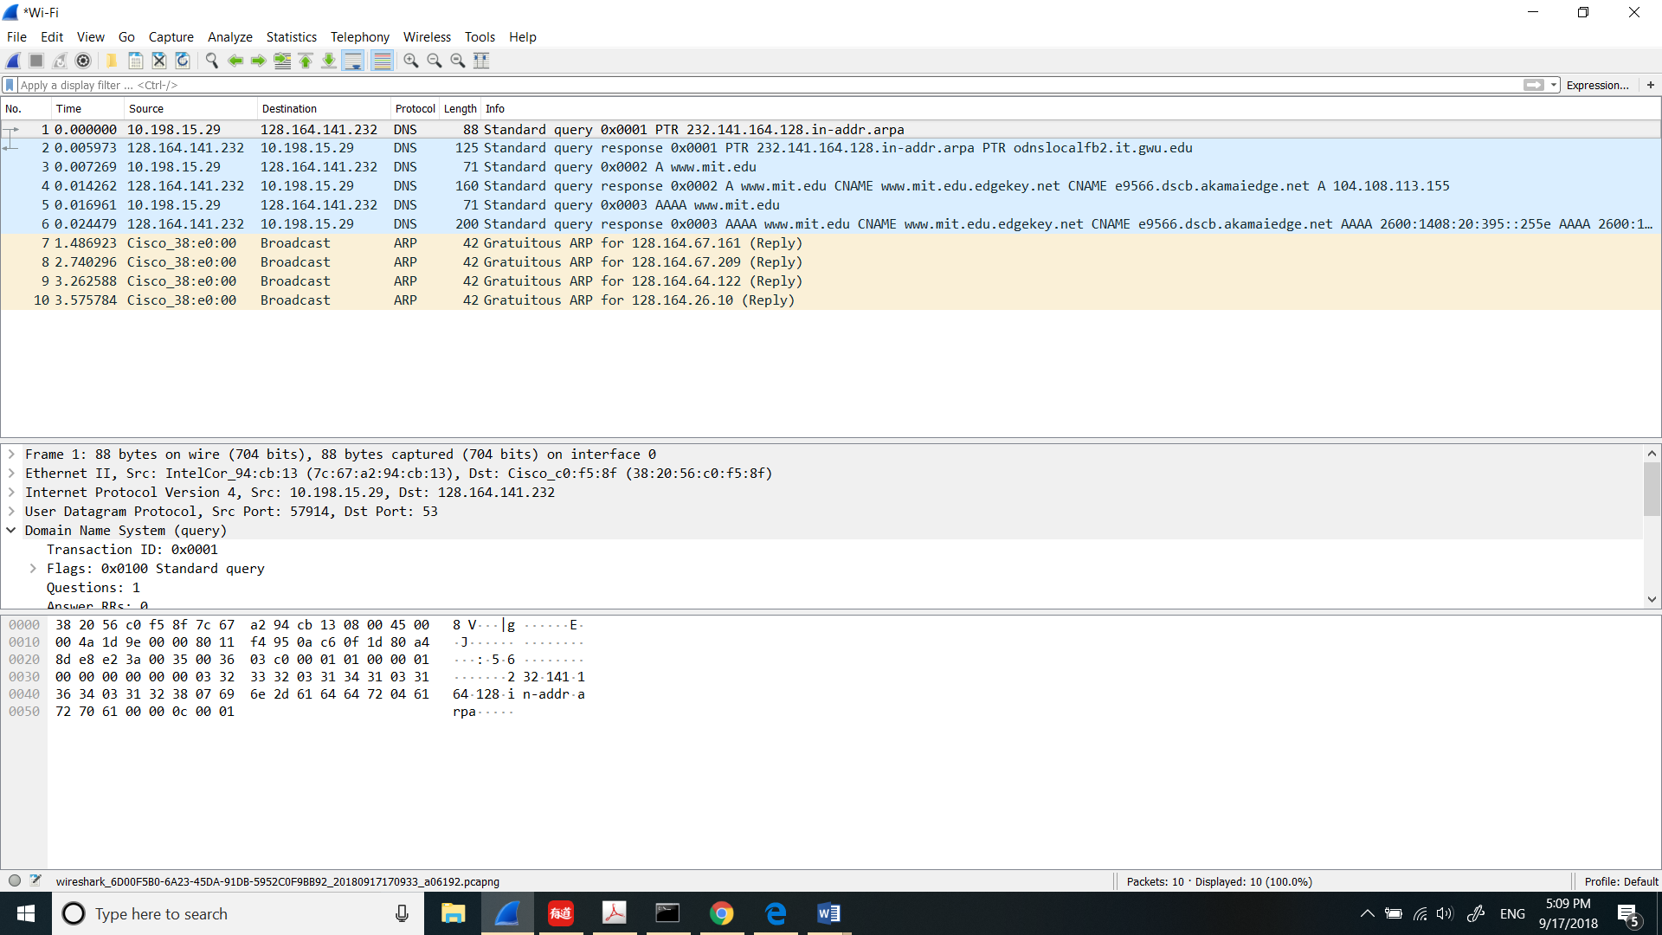
2. 128.164.141.232. Yes
3. Type NS query. No
4. mit.edu nameserver = eur5.akam.net

mit.edu nameserver = use2.akam.net

mit.edu nameserver = asia2.akam.net

mit.edu nameserver = ns1-173.akam.net

mit.edu nameserver = use5.akam.net

mit.edu nameserver = asia1.akam.net

mit.edu nameserver = usw2.akam.net

mit.edu nameserver = ns1-37.akam.net

No IP address.

1. 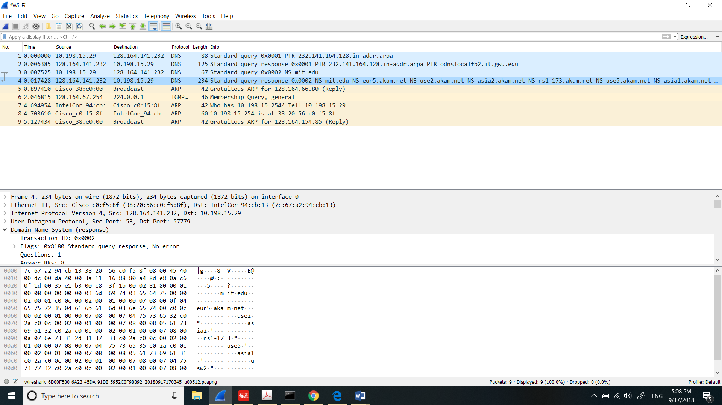
2. 128.164.141.232. Yes.
3. It is a type AAAA query. No
4. One answer.

